Gyro Stabilizer Configuration File
Country |  |  |  | Ship owner ssssskkkkkOOOoOowner
Builder |  |  |  | Contact
Tel |  |  |  | Fax
Ship Type |  |  |  | Date
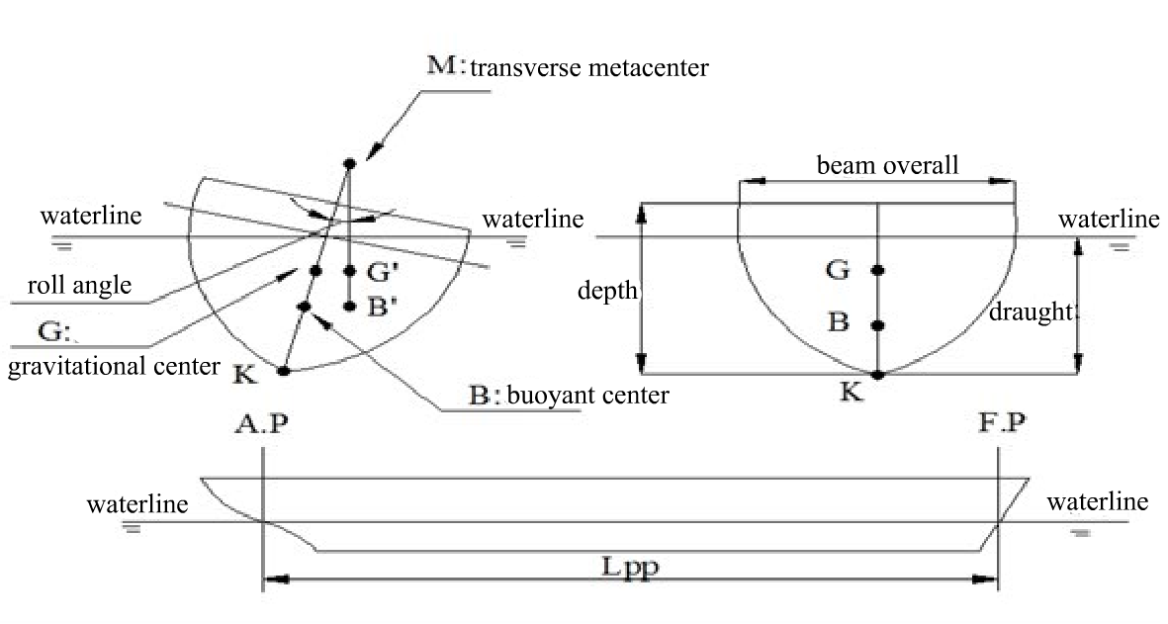
1 | (Lpp) Length overall* |  |  |  |  | m
2 | Draught |  |  |  |  | m
3 | Depth |  |  |  |  | m
4 | Beam overall* |  |  |  |  | m
5 | Initial roll metacentric height (GMt) |  |  |  |  | m
6 | Gravitational center height |  |  |  |  | m
7 | Displacement* |  |  |  |  | ton
8 | Natural roll period |  |  |  |  | s
9 | Significant wave height |  |  |  |  | m
10 | Roll angle |  |  |  |  | degree
11 | Roll angle with stabilizer（expected） |  |  |  |  | degree
Note：1. Fields marked with “*” are required.
2. Please attach other user requests.
 |  |  | JIWU TECHNOLOGY  No.6255,Beisong Rd, Songjiang, Shanghai, China  www.jiwutech.com  sales@jiwutech.com  Mr. Bob Hong  Cell: +86 138 0192 2637  Email:Bob.Hong@ JIWUTECH.com

